**COURSE: STATISTICAL EXPERIMENTATION THEORY**

**DATACAMP ASSESMENT**

**MCQ’S ANSWERS**

**PART II**

**TOTAL 15 QUESTIONS**

BELOW ATTACHED THE SCREEN SHOTS OF THE QUESTIONS AND ANSWERS.

**1)**

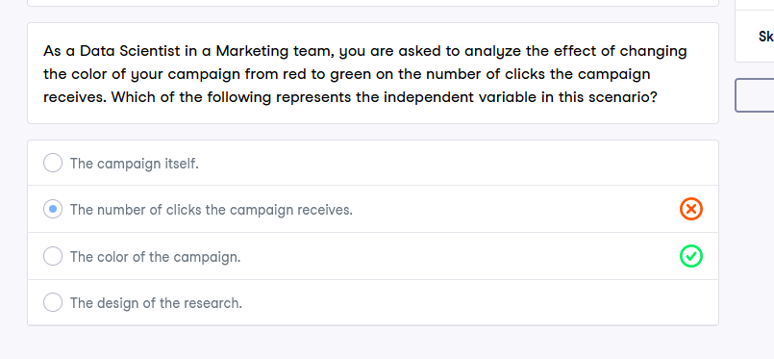

**2)**

**3)**

**4)**

**5)**

**6)**

**7)**

**8)**

**9)**

**10)**

**11)**

**12)**

**13)**

**14)**

**15)**

